1. Introduction

The operations software for the L-Band Satellite Tracking and Characterization System is responsible for providing an interface between the user and the system's hardware components. It allows the user to input commands, receive system status updates, and manage recorded data. The software consists of several modules that communicate with each other to provide a seamless experience for the user.

Software Architecture

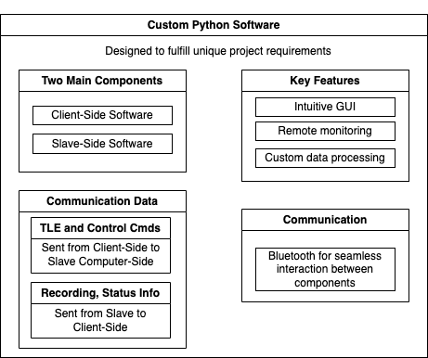

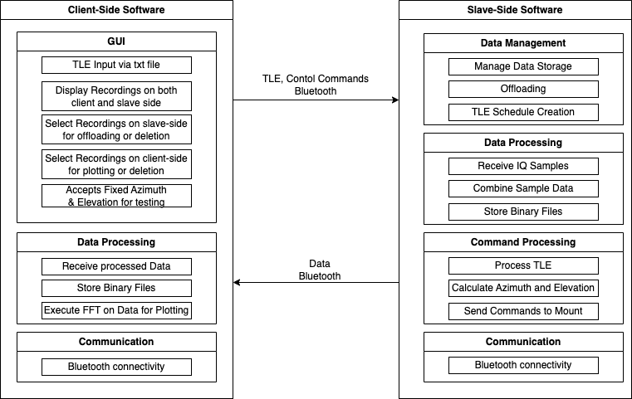

The software architecture consists of the following main components:

User Interface (GUI)

Client-Server Communication (CSComm)

Server-Client Communication (SCComm)

DataManager

DataProcessor

TLEParser

RTL-SDR Interface

YaesuRotator Interface

2.1 User Interface (GUI)

The GUI provides an intuitive interface for users to interact with the system. Users can input TLE data, send control commands, select recordings, request offload of recordings, and input fixed azimuth and elevation.

2.2 Client-Server Communication (CSComm)

CSComm is responsible for facilitating communication between the GUI and SCComm. It transmits TLE data, control commands, recording selections, and offload requests from the GUI to SCComm.

2.3 Server-Client Communication (SCComm)

SCComm receives data and commands from CSComm, processes the received data, and executes the commands. It communicates with DataManager and DataProcessor to manage and process data.

2.4 DataManager

DataManager is responsible for scheduling satellite passes, managing recordings, and offloading recordings based on user input. It communicates with TLEParser, DataProcessor, RTL-SDR Interface, and YaesuRotator Interface to perform these tasks.

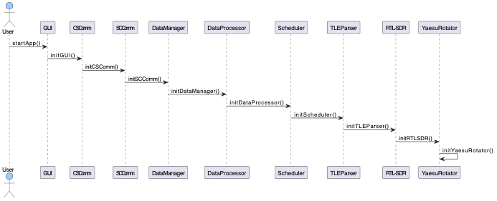

2.5 DataProcessor

DataProcessor processes the TLE data received from DataManager and calculates satellite positions. It also processes recordings and provides processed data to the GUI.

2.6 TLEParser

TLEParser parses the TLE data received from DataProcessor and returns the parsed data to DataManager. It is responsible for converting raw TLE data into a format that can be used by other components.

2.7 RTL-SDR Interface

The RTL-SDR Interface communicates with the RTL-SDR hardware to configure the device, receive samples, and store the recorded data.

2.8 YaesuRotator Interface

The YaesuRotator Interface communicates with the Yaesu rotator hardware to control the antenna's position based on the input azimuth and elevation or calculated satellite positions.

Implementation

The operations software will be implemented using Python, as it provides extensive libraries for handling communication, data processing, and interfacing with hardware components. The GUI will be developed using PyQt, a Python library for creating desktop applications.

3.1 Required Libraries

bluetooth (for Bluetooth communication)

rtlsdr (for RTL-SDR interface)

serial (for YaesuRotator interface)

skyfield (for TLE parsing and satellite position calculation)

PyQt (for creating the GUI)

3.2 Test Code

